8.3: a) 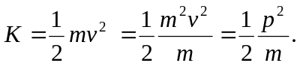

b) From the result of part (a), for the same kinetic energy, 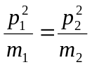, so the larger mass baseball has the greater momentum; 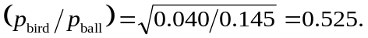 From the result of part (b), for the same momentum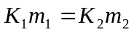, so 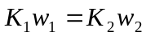; the woman, with the smaller weight, has the larger kinetic energy. 